TAMU Sketch Recognition Data Collection Program

I. Program Description

The data collection program allows users to collect sketch and speech data simultaneously. It includes additional features such as changing stroke color during sketching and allowing an image to be displayed in the background (i.e. a map). Sketch data is saved in the form of an XML file while speech data is saved as a WAVE file.

II. Setting up Collection Study

Creating a collection study requires a single configuration file along with an optional background image (PNG or JPEG formats preferred). The configuration file should be an ASCII text file containing a list of descriptions of the objects or scenarios that should be collected. Each description is denoted by a new line in the file (i.e. there should be one description per line in the text file). An example collection file would be:

Friendly Ground Unit
Friendly Air Unit
Friendly Subsurface Unit
Hostile Ground Unit
Hostile Air Unit
Hostile Subsurface Unit

example_collection.txt

Once a configuration file is created, the program can be executed with the following Java command. *Note* It is recommended that this Java command be saved in a batch file or shell script for easy execution.

Usage:

java –classpath .;TAMUCollection.jar org.ladder.collection.SimpleCollection [arg1] [arg2] [arg3] [arg4] [arg5]

Arguments:

[arg1] - location of the collection file (ex: example_collection.txt)

[arg2] - boolean ("true" or "false") specifying if study should be random or not

[arg3] - location of the folder to save the data to (ex: data)

[arg4] - location of an image to display as the background (ex: map.png); use "." for no map

[arg5] - boolean ("true" or "false") specifying if the study should allow audio capture or not

III. Performing a Study

Upon execution of the above Java command, the data collection program should open.

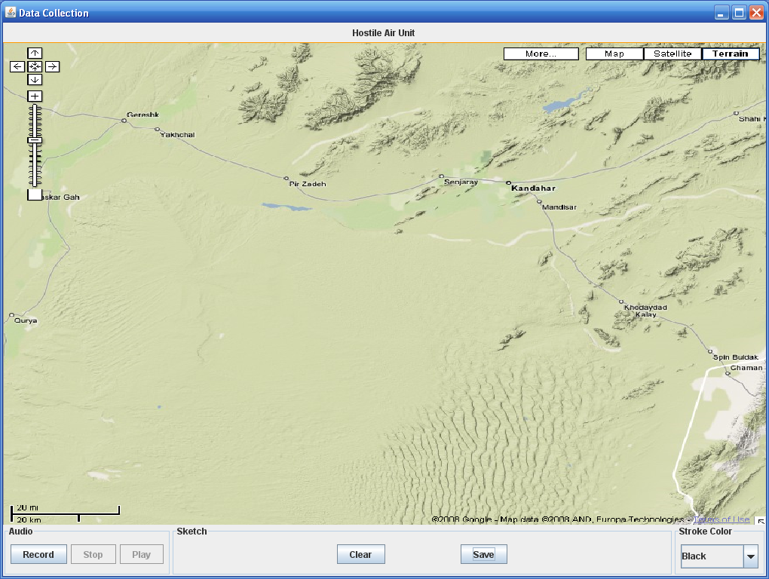

The collection program allows users to sketch directly on the map image (or blank screen if no map is specified) and provides three control sections at the bottom of the application:

1. Audio section: provides functionality for speech recording. The user or collection administrator must press the record button to start audio recording. Note: Speech does not begin recording automatically at program start. At any time during the session, speech collection may be stopped and played back. If speech collection is stopped and the record button is pressed again, the previous speech file will be overwritten.

2. Sketch section: provides functionality for clearing and saving a sketch. The clear button can be used to clear the screen of all strokes. The save button is used to save the current sketch (and speech) to file and proceed to the next object to be collected (if applicable).

3. Stroke color section: provides user ability to change the stroke color. Colors are often used for annotating certain parts of sketches. All color information is saved automatically in the sketch object.

